ASSIGNMENT 3

AIM:
To plot transfer characteristics of NMOS and PMOS transistors for different Vgs and Vds.
CIRCUIT:
1. NMOS
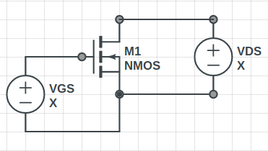

2. PMOS
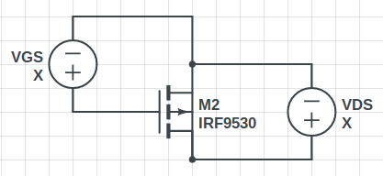

MAGIC LAYOUT:
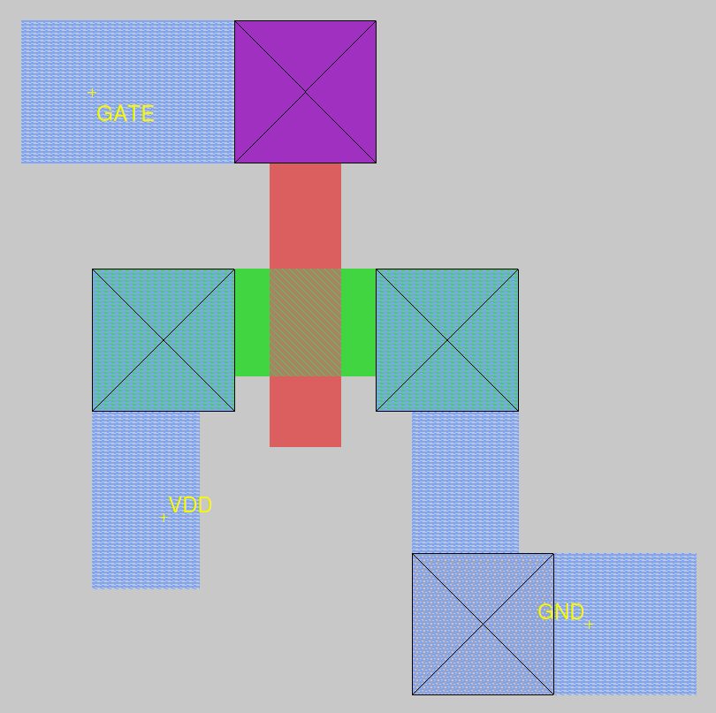
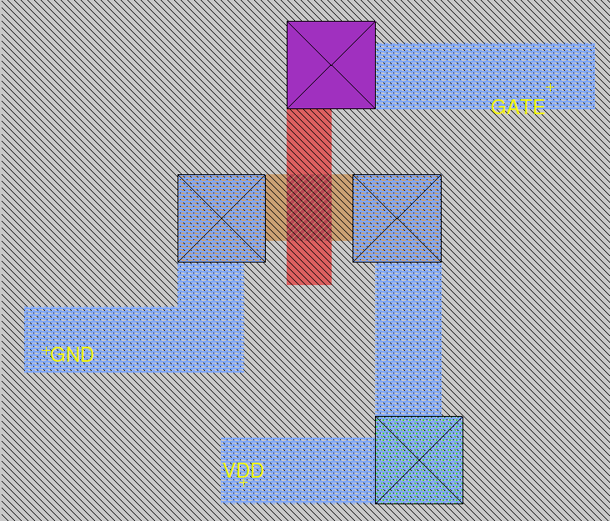

NMOS PMOS

OBSERVATIONS:
1. NMOS Transfer Characteristics
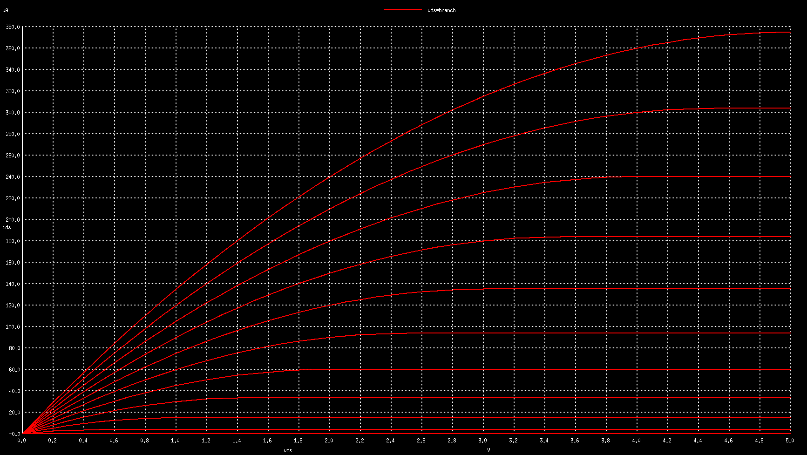

2. PMOS Transfer Characteristics
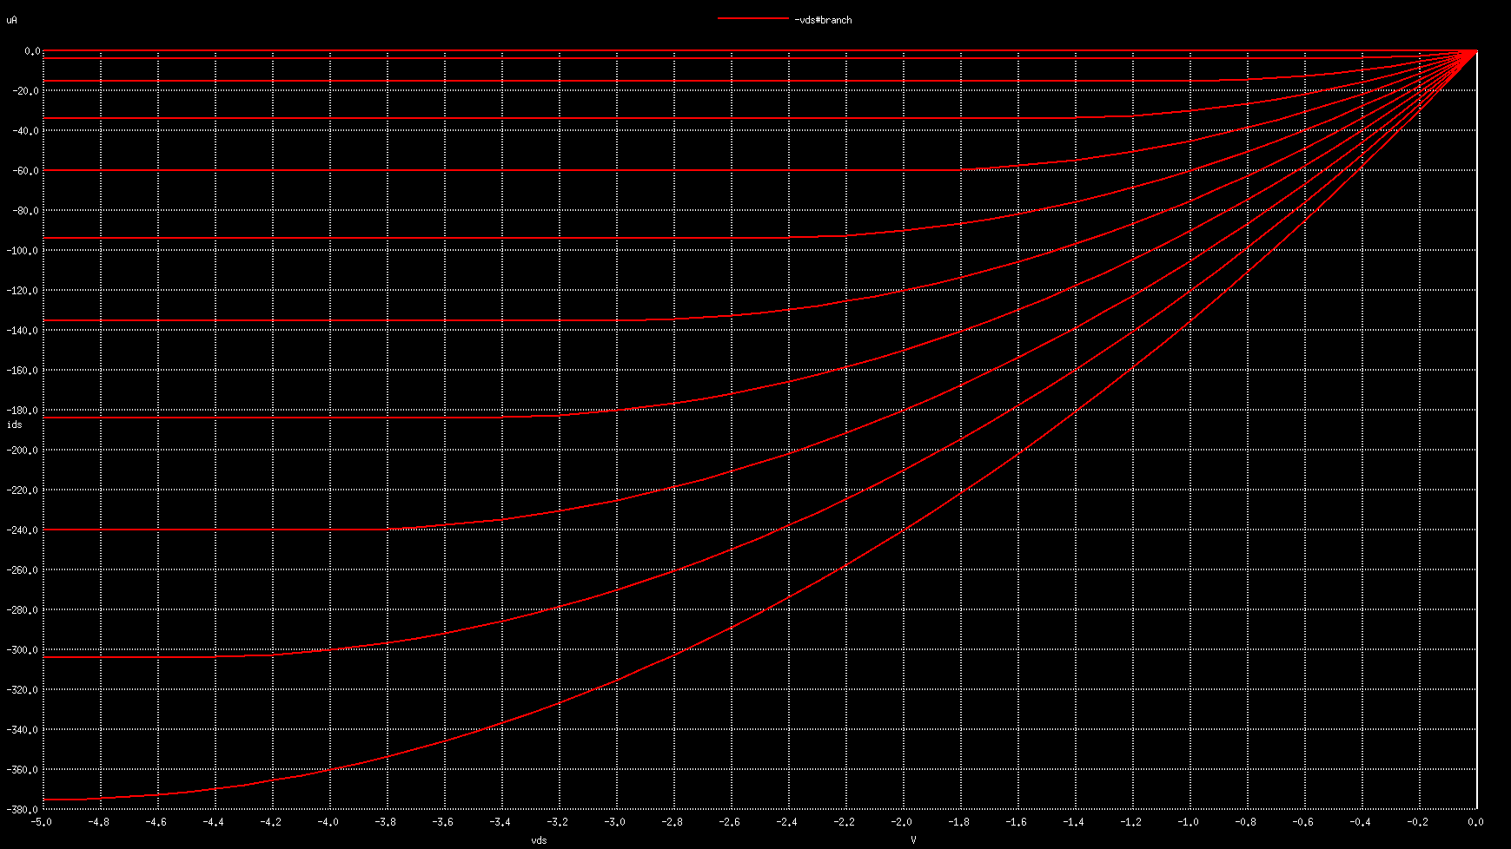
CONCLUSION:
Default NMOS and PMOS configurations were used and the transfer function graph matched the theoritical analysis for long channel MOSFETS.

